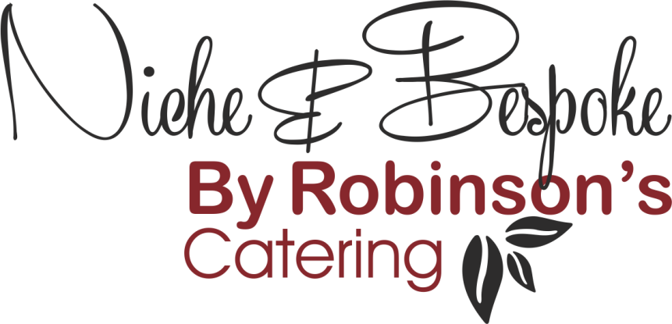

Refined Catering for
Executive Aviation – Events – Corporate Hospitality

Hot Buffet
Mains
- Pan Fried Chicken Breast, Chasseur Sauce, Creamed Potatoes

- Slow Cooked Pork Rib-Eye, Braised Red Cabbage, Boulanger Potatoes

- Lamb Tagine, Freekeh Wheat, Roasted Vegetables, Almonds, Apricots (N)

- Beef Massaman Curry, Basmati Rice, Pineapple & Mango Chutney

- Traditional Fish Pie with Red Leicester & Chive Mash

- Shepherd’s Pie

- Chicken Fricasse with Mushrooms & Leeks in a White Wine Sauce

- Char Sui Glazed Pork Belly, Roasted Squash & Stir-Fried Vegetables

- Beef Lasagne, Garlic Mushrooms, Parmesan Glaze

- Mushroom Stroganoff, Baby Onions, Wild Rice (V)

- Vegetable Katsu Curry, Jasmine Rice, Pickled Sesame Vegetables (V)

- Baked Vegetables, Tomato Fondue, Potato Gnocchi, Mozzarella Glaze (V)
Served with a selection of Seasonal Vegetables and Salads

Desserts
- Baked New York Cheesecake, Berry Compote

- Chocolate & Pecan Brownie, Poached Pear, Chantilly Cream & Raspberries (N)

- Apple & Sultana Crumble Tart, Vanilla Custard

- Fresh Seasonal Fruit Salad, Whipped Greek Yoghurt, Honey & Granola (N)

- Dark Chocolate Mousse, Salted Caramel, Honeycomb

- Buttermilk Panna Cotta, Poached Peach, Crushed Raspberries

- Cherry Bakewell Tart, Amaretto Chantilly (N)

(V) Suitable for Vegetarians
(N) Contains Nuts

