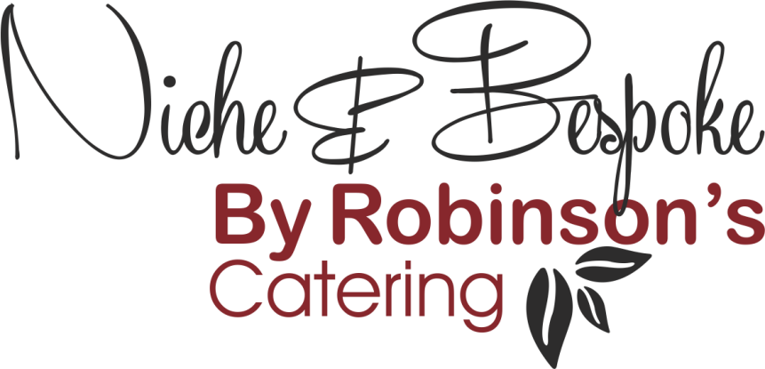

Refined Catering for
Executive Aviation – Events – Corporate Hospitality

3 Course Meal
Menu 1
- Heritage Tomato Salad, Buffalo Mozzarella, Smoked Pepper & Basil Dressing
- Roast Breast of Chicken, Stuffed Leg, Fondant Potato, Hispi Cabbage, Sun-Blushed
- Tomatoes, Portobello Mushroom with Confit Garlic
- Baked Vanilla Cheesecake, Summer Fruit Compote
Menu 2
- Beetroot & Asparagus Salad, Whipped Goat’s Cheese, Red Onion Granola (N)
- Roast Pork Loin, Pulled Pork Croquette, Roasted Summer Vegetables, Barbeque Sauce
- Dark Chocolate Torte, English Strawberries, Vanilla Chantilly, Passion Fruit Sauce
Menu 3
- Chicken & Ham Hock Terrine, Pickled Summer Vegetables, Mustard Dressing
- Poached Salmon Fillet, Fricassée of Peas, Broad Beans & Asparagus, Warm New Potato Salad, Charred Gem Lettuce
- Summer Pudding with Clotted Cream
Menu 4
- Smoked Trout Mousse, Brixham Crab, Dressed Prawns with Lemon & Dill
- BBQ Lamb Rump, Courgettes Provençale, Crushed Potatoes, Roast Garlic & Aubergine Puree
- Lemon Posset, Eton Mess, Pimms Jelly
Menu 5
- Gin Cured Salmon, Charred & Pickled Cucumber, Caspian Sauce
- Cannon of Beef (Sirloin), Green Beans & Pancetta, Dauphinoise Potatoes, Ox Cheek Bordelaise
- White Chocolate & Champagne Torte, Candied Pistachios, Strawberries & Mint (N)

Vegan Menu
- Sweet Potato Falafel, Baby Spinach & Watercress Salad, Whipped Tahini, Grilled Pitta
- BBQ Broccoli, Smoked Tofu, Jackfruit Satay, Charred Lime (N)
- Chocolate Tart, Salted Caramel, Strawberries, Almond Yoghurt (N)

(N) Contains Nuts
All menus include crockery, cutlery & napkins
Additional linen/tablecloth hire, tables, chairs & staff can be provided
Please make us aware of guests that have any food intolerances or allergies at least 24 hours prior to the time of your event

