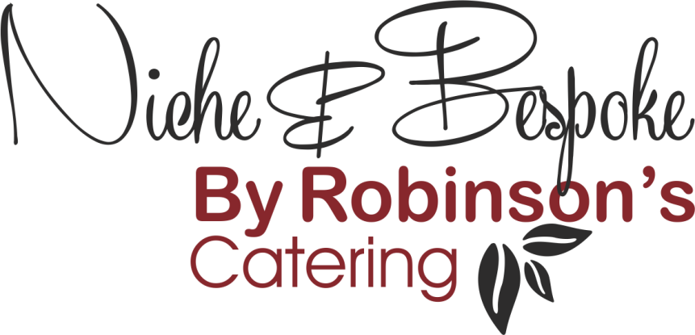

Refined Catering for
Executive Aviation – Events – Corporate Hospitality

Finger Buffet and Bowl Food
- Selection of Sandwiches: to include Fish, Meat & Vegetarian options

- Filled Tortilla Wraps: Chicken Caesar Salad, Tuna Niçoise, Spicy Vegetable & Guacamole

- Open Sandwiches on Baguette Slices: Rare Roast beef, Rocket & Mustard / Smoked Salmon & Herb Cream Cheese / Tomato, Mozzarella & Basil

- Mini Brioche Buns filled with Cocktail Prawns

- Falafel with Smoked Pepper Hummus

- Marinated Chicken Skewers with Satay Sauce (N)

- King Prawn Lollipops with Aioli

- Baby Mozzarella, Cherry Tomato & Olive Skewers Dressed in Pesto (N)

- Smoked Haddock, Leek & Cheddar Tartlets

- Red Onion & Goat’s Cheese Quiche

- Vegetable Crudities with Guacomole

- Bruschetta: Spicy N’duja / Marinated Sardine & Peppers / Grilled Vegetable & Hummus

- Oatcakes topped with: Whipped Chicken Livers & Grape Chutney / Smoked Mackerel & Horseradish / Creamed Stilton & Pickled Walnut

- Vol au Vents filled with: Smoked Ham & Mushroom / Poached Salmon & Dill / Sun-Blushed Tomato & Cream Cheese

- Lettuce Cups filled with: Shredded Beef & Hoi Sin / Crab, Sweetcorn & Ginger / Vietnamese Style Vegetables

- Pork Pie with Pickles

- Beef Sliders with Monterey Jack Cheese & Jalapenos Mayo

- Salmon & Spring Onion Fishcakes, Sauce Gribiche

- Leek & Cheddar Cheese Quiche (V)

- Chicken Yakitori Skewers

- Filo Wrapped King Prawns with Sweet Chilli Sauce

- Garlic Mushroom Bruschetta (V)

- Pulled Pork, BBQ Sauce, Brioche Bun

- Smoked Haddock Rarebit

- Vegetable & Pinto Bean Quesadillas (V)

- Venison Scotch Eggs

- Pancetta Wrapped Scallops with Herb Butter

- Halloumi & Vegetable Kebabs with Baba Ghanoush

- Hot Game Pies with Cumberland Sauce

Bowl Food

- Stir Fried Noodle Salad with Edamame Beans & Sesame Dressing (V)

- Roast Butternut Squash, Pancetta, Parmesan & Rocket

- Traditional Paella

- Venison Cottage Pie

- Lentil & Quinoa Salad, Charred Broccoli & Shitake Mushrooms (V)

- Anti-Pasti with Risoni Pasta (V)

- Blackened Cod, Brown Rice, Thai Green Curry

- Beef Massaman Curry

- Smoked Haddock & Salmon Kedgeree

- Smoked Turkey, Chestnut & Sprout Top Salad

- Salt-Baked Celeriac & Kale Waldorf Salad

Sweet

- Seasonal Fruit Tartlets

- Portuguese Custard Tarts

- Millionaire’s Shortbread

- Crème Brûlée

- Warm Mince Pie with Brandy Butter

- Christmas Pudding Rocky Road

- Bailey’s & Chocolate Mousse with Brandy Snap Straws

- Clementine Cheesecake with Prosecco Jelly

- Winter Berry Fool with Cranberry Granola

(N) Contains Nuts
(V) Suitable for Vegetarians
Variations and substitutions can be made to suit dietary requirements.

Refined Catering for
Executive Aviation – Events – Corporate Hospitality

Cold Fork Buffet
- Selection of Anti-Pasti (V)
- Cured Continental Meats
- Smoke Salmon, Dressed Prawns, Capers & Lemon

*******************************************************
- Honey-Glazed Ham, Smoked Turkey & Roast Beef
- Spinach, Mushroom & Berkswell Quiche (V)
*******************************************************
- Potato Salad with Crème Fraiche & Garlic Cloves
- Tomato & Red Onion Salad with Basil Dressing
- Winter Vegetable Coleslaw
- Mixed Leaf Salad with Mustard Vinaigrette
*******************************************************
- Profiteroles with Salted Caramel Cream and Chocolate Sauce
- Poached Winter Fruit, Whipped Greek Yoghurt, Cranberry Granola

Refined Catering for
Executive Aviation – Events – Corporate Hospitality

Hot Fork Buffet
- Dressed Poached Salmon, Potted Shrimps, King Prawns with Aioli
- Hand-raised Game & Pork Pie with Pickles & Chutney
- Vegetable Gyoza Dumplings with Dipping Sauces (V)

*******************************************************
- Roast Rib of Beef, Yorkshire Pudding & Roasted Juices
- Slow-Roasted Pork Belly, Spiced Apple Compote
- Vegetable Gratin with Warwickshire Truckle Cheese (V)
- Roast Potatoes
- Seasonal Vegetables Glazed with Herb Butter
*******************************************************
- Cracked Wheat Tabouleh Salad (VG)
- Charred Broccoli, Carrot & Cashew with Asian Dressing (VG)
- Classic Caesar Salad
- Marinated Tomatoes with Artichokes & Bocconcini (V)
- Spiced Bean & Chopped Vegetable Salad (VG)
*******************************************************
- Sticky Toffee Pudding with Butterscotch Sauce
- Raspberry & Passion Fruit Pavlova with Raspberry Coulis
- Seasonal Fruit Crumble with Vanilla Custard
- Poached Pears with Clotted Cream & Chocolate Sauce

(N) Contains Nuts
(V) Suitable for Vegetarians
(VG) Vegan Friendly

Our dishes are freshly prepared using seasonal ingredients and are therefore subject to availability, in some cases, ingredients may be changed or substituted without notice.

A complete list of allergen information is available on request.

We will always do our upmost to cater for the individual needs of our clients and we are happy to adjust dishes to allow for dietary requirements; to allow us to do this, we ask for a minimum of 48 hours prior notice of any such requirements or any food allergies/intolerances.

Our production unit produces food for multiple sectors so we are unable to guarantee that our dishes are completely free from traces of food allergens.

