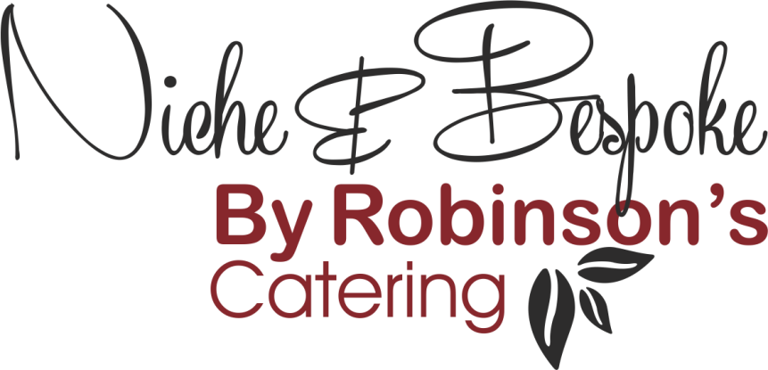

Refined Catering for
Executive Aviation – Events – Corporate Hospitality

Breakfast
- Traditional Cereals & Museli – individual bowls with separate portions of milk or plant based alternative

- Fresh Fruit Bowl with Natural Yoghurt / Soya Yoghurt (V/VG)

- Whipped Greek Yoghurt, Fruit Compote & Granola (V)

- Overnight Oats, Fresh Mango & Chai Seeds (V/VG)

- Breakfast Buddha Bowls:
Brown Rice, Eggs & Avocado (V)
Rancher’s Eggs, Pinto Beans & Roast Peppers (V)
Scrambled Tofu, Spiced Sweet Potato & Chickpeas (VG)

- Bakery Items: Croissants, Danish Pastries, Pan au Chocolate (V)

- Individual Breakfast Sandwiches:

“Bacon Butty” on Farmhouse Bread or Soft Bap
Grilled Sausage n White, Wholemeal or Sourdough
Bacon, Sausage & Egg on White, Wholemeal or Sourdough

Wholemeal Bagel, Crem Cheese, Smoked Salmon & Avocado
Brioche Bun, Prosciutto Ham, Emmental Cheese & Tomato

- Breakfast Burritos:
Hash Brown, Smoked Bacon, Egg & Salsa
Vegan Tofu, Peppers, Spiced Potato & Avocado (VG)

- English Muffins:
Pork Sausage, Bacon & Egg
Smoked Salmon & Egg
Vegetable Pattie & Egg (V)

- Sweet Items:
Belgian Waffles, Dark Chocolate Sauce, Banana Fool
Blueberry or Double Chocolate Muffins

- Basket of Fresh Fruit to include: Apples, Easy Peel Oranges, Pears, Plums, Bananas and seasonally available fruit (minimum of 20 pieces per basket)

(V) – Suitable for Vegetarians
(VG) – Suitable for Vegans

