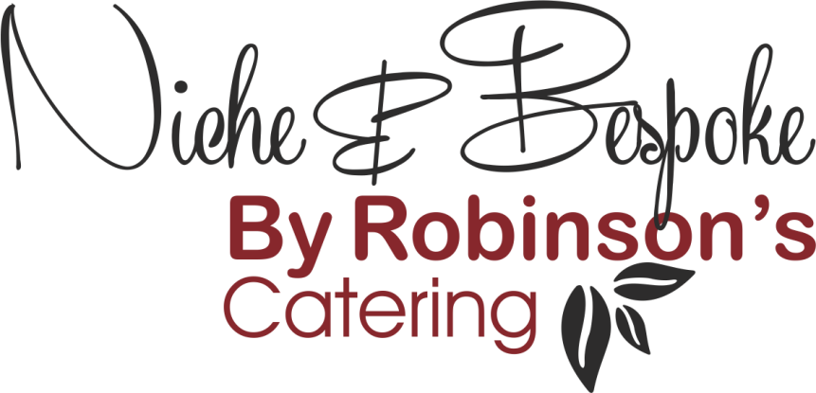

Refined Catering for
Executive Aviation – Events – Corporate Hospitality

Working Lunch & Grab n Go Solutions

- Individual sandwich platter of finger sandwiches, tortilla wrap & pitta bread pockets, various fillings created with seasonality and dietary requirements in mind.

Fillings:
- Italian Chicken, Sun-Dried Tomato & Rocolla
- Smoked Turkey, Turkey Bacon & Romaine Lettuce with Low Fat Caesar Dressing
- Roast Beef, Rocket & Smoked Peppers
- Barbeque Pulled Chicken with Salad & Coleslaw
- Tuna Nicoise
- Cajun Spiced Salmon Salad
- Piri Piri Prawns with Avocado
- Roasted Mediterranean Vegetable Salad with Hummus (VG)
- Spiced Peppers & Guacamole (VG)
- Feta Cheese with Greek Style Salad (V)
- Cheddar Cheese & Onion Chutney (V)
- Soy Marinated Tofu with Spring Onion & Pea Shoot Salad (VG)

- Buddha Bowls:

- Buttermilk Chicken, Romaine Lettuce, Sweetcorn, Caesar Dressing
- Hawaiian Tuna Poke, Quinoa, Mango Salsa
- Spiced Tofu, Asian Vegetables, Jasmine Rice
- Roasted Vegetables, Za’atar, Couscous Tabouleh
- Confit Salmon, English Garden Salad, Avocado & Pink Grapefruit
- Ham, Cheddar Cheese, Ploughman’s Pickles & Tomatoes

- Bao Buns:

- Hoi Sin Duck & Asian Vegetables
- Sweet & Sour Vegetables, Jack Fruit & Srircha

- Panini Sandwiches:

- Tomato, Mozzarella & Pesto
- Prosciutto Ham, Provolone & Tomato
- Tuna & Red Leicester Melt

- Bento Boxes: (Japanese style single portion, pre-packed meal consisting of protein, carbohydrate & vegetables)

- Katsu Chicken, Basmati Rice, Stir Fried Vegetables
- Miso Glazed Salmon, Udon Noodles, Sesame Vegetables
- Vegetable Dim Sum, Singapore Noodles, Tofu Rendang
- Italian Spiced Meatballs, Penne Napolitano, Grilled Vegetables
- Slow-cooked Beef Brisket, Creamed Potatoes, Succotash
- Spiced Cod, Prawn Jambalaya, Cajun Vegetables
- Roasted Tofu, Bell Peppers, Chilli Beans, Quinoa

- Desserts

- Lemon Drizzle Cake, Raspberries & Mascarpone
- Whipped Greek Yoghurt, Poached Apricots, Almond Granola
- Belgian Chocolate Mousse, Salted Caramel, Honeycomb
- Coconut Panna Cotta, Pineapple, Chai Seeds
- Seasonal Fruit Pots
- Vegan Eton Mess

- Snacks

- Pipers Crisps (Sea Salt, Sea Salt & Cider Vinegar, Cheddar & Onion)
- Confectionary (Mars, Twix, Snickers, KitKat, Bounty, Twirl)

(V) Suitable for Vegetarians
(VG) Suitable for Vegans

