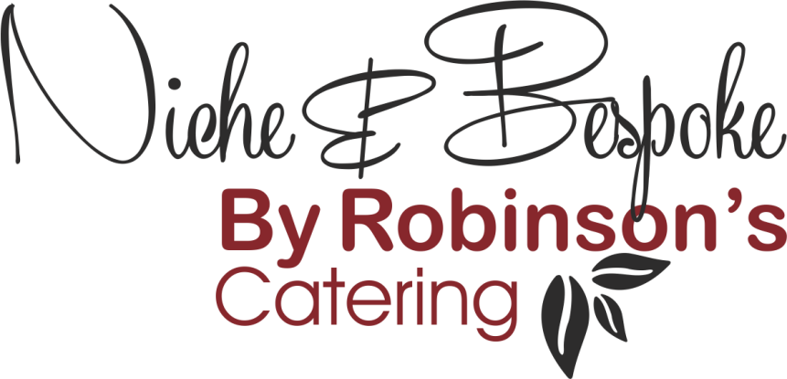

Refined Catering for
Executive Aviation – Events – Corporate Hospitality

Canape Menu
Cold
- Cherry Tomato, Smoked Aubergine & Pine Nut (V)

- Whipped Goats Cheese, Tomato & Chilli Jam (V)

- Duck Liver & Sour Cherry Bon-Bon

- Tuna, Watermelon & Wasabi

- Asparagus & Berkswell Cheese Tartlets (V)

- Cocktail Prawns, Avocado, Seaweed Tapioca Cracker

- Beef Tartare, Charcoal Mayo

- Severn & Wye Smoked Salmon, Dill Blini

- Quail Egg, Mushroom & Watercress Tartlet (V)

- Cotswold Salami, Pickled Vegetables, Black Olive Crostini

- Smoked Chicken & Avocado Gem Lettuce Wrap, Caesar Dressing

- Devilled Mushroom & Quail Egg Tartlet (V)

- Gin-cured Salmon, Cream Cheese & Rye Bread

- Venison Tartare, Charcoal Mayo

- Whipped Duck Liver Parfait & Sour Cherry Cone

- Cranberry Glazed Stilton Bon-Bon (V)
- Tuna Ceviche, Avocado, Tortilla

- Smoked Trout Mousse, Trout Caviar & Dill Blini

- Cured Ham Crostini with Date Chutney

- Whipped Goat’s Cheese, Fig, Almonds & Honey (V)

Refined Catering for
Executive Aviation – Events – Corporate Hospitality

Canape Menu
Hot
- Evesham Asparagus, Pershore Ham, Hollandaise Sauce

- Crispy King Prawns, Smoked Tomato Ketchup

- Honey & Soy Glazed Chicken Skewer

- Salt-Baked Jersey Potato, Chive Crème Fraiche (V)

- Cornish Crab Fritter, Lemon & Herb Mayo, Smoked Paprika

- Pea Tartlet, Feta Crumble, Kalamata Olive (V)

- Char Sui Pork Belly, Puffed Wild Rice

- Sesame Crusted Salmon, White Radish, Baby Coriander

- Puff Pastry, Caramelized Onion, Warwickshire Truckle, Onion Seeds (V)

- Charred Mackerel, Pepper Compote, Basil

- Spiced Cauliflower, Apple Chutney, Pickled Mustard Seeds (V)

- Chorizo Scotch Egg

- Falafel with Spiced Beetroot Ketchup (VG)

- Honey & Mustard Glazed Pigs in Blankets

- Salt & Pepper Chilli King Prawns

- Berkswell Cheese Tartlet with Spiced Apple & Raisin Chutney (V)
- Pulled Pork Sausage Rolls

- Crab Arancini, Smoked Pepper Aioli

- Winter Vegetable Empanadas, Mojo Sauce (V)

- Ox Cheek Croquettes with our Brown Sauce

- Beer Battered Cod, Pea Puree & Tartare Sauce

Refined Catering for
Executive Aviation – Events – Corporate Hospitality

Canape Menu
Sweet
- Assortment of Chocolate Bon Bons
- Chocolate Lollipops
- Strawberry & Tonka Bean Tartlets
- Salt Caramel Profiteroles
- Mini Cornettos (Mint Choc Chip or Rum and Raisin)
- Mini Scones, Jam & Clotted Cream
- Assorted Macaroons (N)
- Mini Black Forest Gateaux
- Mini Eclairs
- Chocolate Doughnuts, Hot Raspberry Sauce
- Clementine Tartlets
- Fruit Kebabs (VG)
- Mini Cheesecakes
- Apple Strudel
- Christmas Pudding Bon-Bons

(V) Suitable for Vegetarians
(VG) Suitable for Vegans
(N) Contains Nuts

