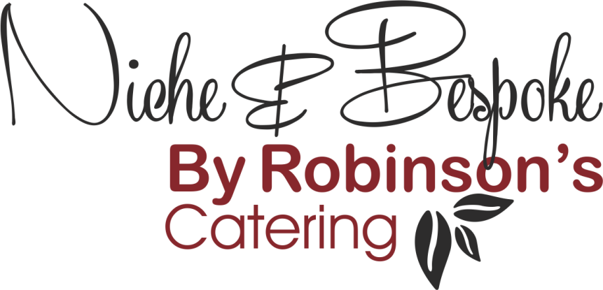

Refined Catering for
Executive Aviation – Events – Corporate Hospitality

Afternoon Tea Menu

Sandwiches & Savoury Items
- Ham, Grain Mustard & Rocket

- Roast Chicken, Lemon & Herb Mayonnaise

- Oak Smoked Salmon, Cream Cheese & Cucumber on Granary Bread

- Egg Mayonnaise, Shallot & Watercress, Wholemeal Bread

- Crayfish Tails, Cocktail Sauce, Brioche Roll

- Cream Cheese, Smoked Pepper & Tomato Tortilla Pin Wheel

- Whipped Goat’s Cheese Bouchée

- Potted Duck & Orange Relish, Rye Cracker

Dessert Items

- Freshly Baked Plain & Sultana Scones with Fruit Conserve & Clotted Cream

- White Chocolate & Raspberry Opera Gateaux

- Caramel & Praline Choux Bun (N)

- Macaron (N)

- Glazed Seasonal Fruit Tartlet

- Pistachio Financier, Dark Chocolate Cremeux, Seville Orange Gel (N)

- Amalfi Lemon Delice

(N) Contains Nuts

