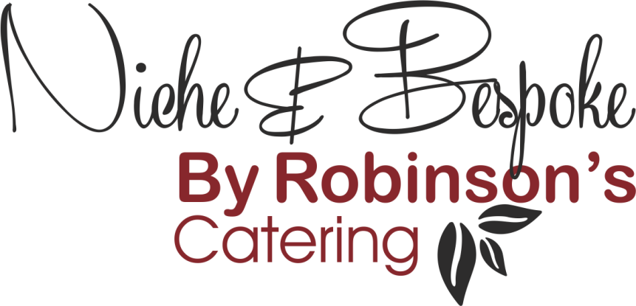

Refined Catering for
Executive Aviation – Events – Corporate Hospitality

BBQ Menu
Menu 1

- Warwickshire Whizzer Sausages, Caramelized Onions, Glazed Hot Dog Roll
- Beef Burger, Cheddar Cheese with Chilli, Floured Bun
- BBQ Marinated Chicken Breast
- Vegetarian Alternative (on request)
- Chunky Tomato Salsa
- Coleslaw

Menu 2

- Piri-Piri Chicken Pieces
- Lamb Kofta, Pitta Bread, Tzatziki
- BBQ Pork Spare Rib
- Beef Burger, Tomato & Herb Relish, Ciabatta Roll
- Vegetarian Alternative (on request)
- Coleslaw
- Potato Salad
- Tossed Mixed Salad

Menu 3

- Tandoori Chicken Skewer, Naan Bread Wrap, Mango Chutney
- Teriyaki Salmon Lollipop
- Corn on the Cob with Jalapenos Butter
- Smokey Glazed Beef Brisket
- King Prawns with Aioli
- Loaded Potato Shells with Guacamole
- Cracked Wheat & Quinoa Salad
- Grilled Watermelon Salad with Feta, Pomegranate & Mint
- Tomato, Baby Mozzarella & Nocerella Olives

Menu 4

- Marinated Lamb Rump
- Beef Rib-Eye, Smoked Garlic & Peppercorn Butter
- Pulled Pork, Mad Goose BBQ Sauce, Brioche Bun
- Grilled Swordfish with Gremolata
- Monkfish, King Prawn & Chorizo Skewer
- Fully Loaded Nachos
- Flat Cap Mushroom, Monterey Jack Cheese, Herb Crumb
- Garlic Sourdough Slices
- Giant Couscous Tabouleh
- Charred Tenderstem Broccoli, Ranch Dressing & Cashew Nuts
- Avocado Salsa
- Salt-Baked Beetroot, Red Onion & Rocket Salad

Appropriate dressings and accompaniment will be provided

All menus include disposable plate, cutlery & napkins

Serving/Waiting staff can be provided

